Documentation Part 3

Jared Osborne



1. Spawn

* Shape: has no function or it doesn’t work correctly.
* The shape can be a line, square, ellipse, and point

1. Spawn Width

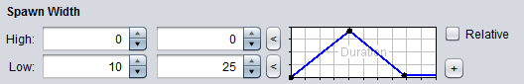

* I’m not sure if this part is working properly I think it is supposed to set the spawn width for the shape specified but it doesn’t seem to function right
* This part is only active if the Spawn Shape is set to line, square or ellipse
* 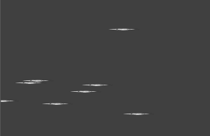The only part that has functionality is the low when it is set it stretches the particle size to the width put in the low boxes
* When low is set to 10 to 25 and on Spawn Height low is zero for both it produces

1. Spawn Height

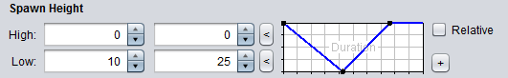

* This part is only active if the Spawn Shape is set to line, square or ellipse
* 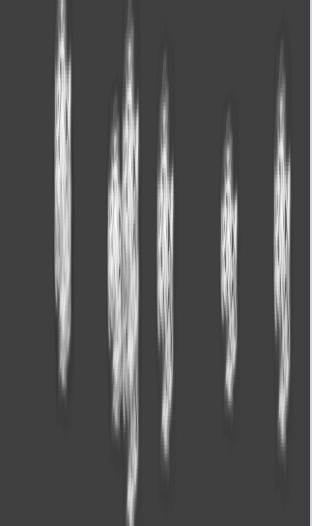Works with Spawn Width only the low has any effect on the particle same as Spawn Width
* When low is set to 10 and 25 and spawn width low is set to zero it produces stretched out particles in the vertical direction
* If Spawn Width has a relatively close value to the low value of the height it will make a normal looking shape as large as the size specified in the size part
* Relative has no effect

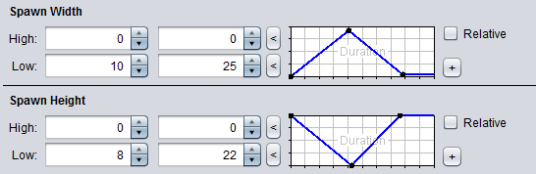

* When both the spawn height and spawn width lows are set near each other it makes a normal looking particle object such as 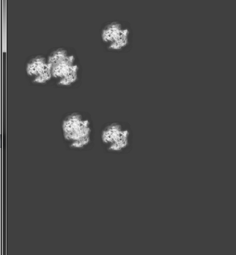

1. 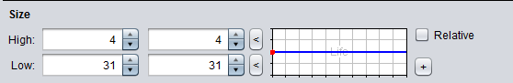Size

* Changes the size of each particle
* The blue line on the graph is the percentage of the high or low that it uses since it is in the middle half of the sizes will be 4 according to high and half will be 31 like low.
* You can set the size between any two numbers that are placed in the two spaces for high and for low causing a mixture of sizes between the numbers specified
* Relative appears to have no effect

1. 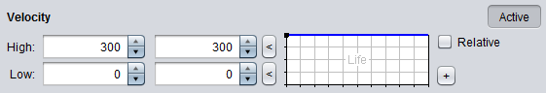Velocity

* The higher the high or low values are the space where the particles are created is increased and the lower the values for high and low are the smaller the space for the particles to be created in.
* If the values are closer to zero it puts the particles in a line 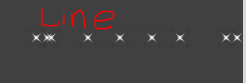

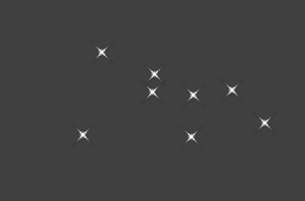 this is when the velocity is above or below zero the farther the number is away from zero the larger the space the particles are allowed to occupy

* Active turns this on or off
* Relative seems to have no effect
* The blue line on the graph determines if the high or low values are selected or a mixture of the two

1. Angle

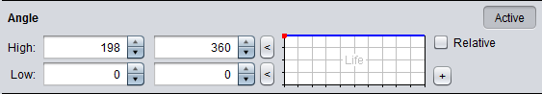

* This seems to make the area for the particles to occupy bigger or smaller depending on the high and low values very similar to the velocity part
* Although if either velocity or angle is near zero it puts all the particles in a line so even if angle has value far from zero and velocity is zero then it will still be in a line like
* The blue line on the graph determines if the high or low values are selected or a mixture of the two
* Active turns this part on or off